

Australian Education Academy Pty Ltd
2006

MATHMATICAL METHODS
UNIT 3 & 4

WRITTEN EXAMINATION 2 - SOLUTIONS

Published by Australian Education Academy Pty Ltd
ABN: 18 104 474 893
292 Mount Alexander Road, Ascot Vale. Vic 3032
Ph: (03) 9370 0666 Fax: (03) 9375 7277
Email: wendy@aust-education.com.au
SECTION A - SOLUTIONS

Question 1

Intercept an x –axis are 0,1,and 2 hence x = 0, x = 1, and x =2 are solution of the function .
hence 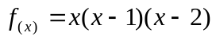is a function . Answer (i)

Question 2

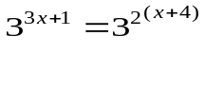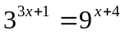

bases are equal hence index are same,
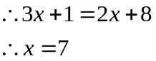
Answer (iv)

Question 3

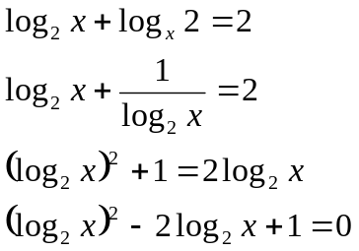

If

Let 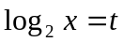
Then 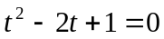
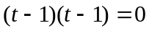
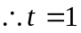 twice.

Then 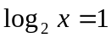
Then 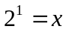
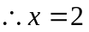 Answer (i)

Question 4

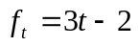 is given function, then let 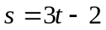
Then 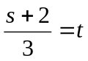
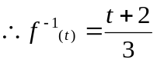
Answer (ii)

Question 5

Mirror image of function 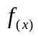 is a reflection of about the line 
Answer (i)

Question 6

When 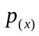exactly divided by
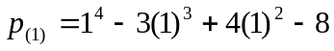
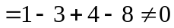
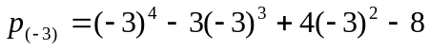
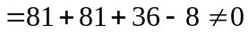
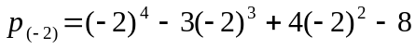
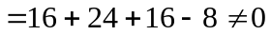
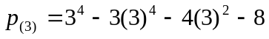
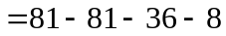
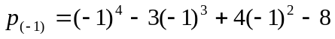
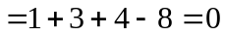
Hence exactly divide by x+1 Answer (v)

Question 7
Let 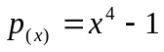
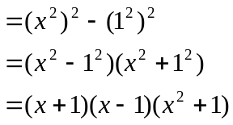
are the factors of 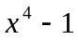 Answer (iii)

Question 8

If 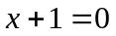 then 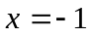
If 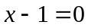 then 
and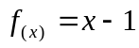 considered,
If 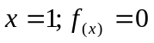 Answer (vi)

Question 9

x =3 is symmetric axis then 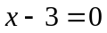and 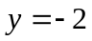is minimum value.
curve has minimum then sign of 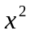must be (+) ve.
According to above data’s 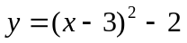 is equation of given function.
Answer (iv)

Question 10

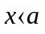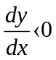

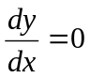
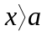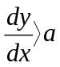

Answer (iv)

Question 11

Substituting given values at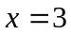numerator and denominator becomes zero. Hence at 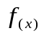 can’t define
Answer (ii)

Question 12

f(x) = 1/ x-1
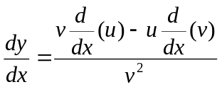
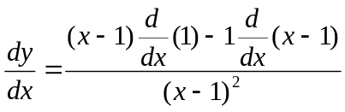

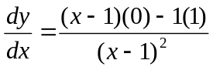

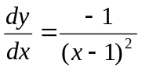 Answer(iii)
Question 13

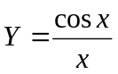 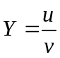 form,

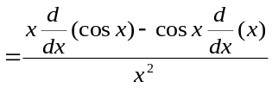

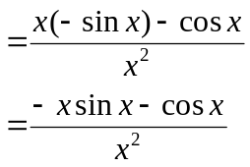

Answer (iv)

Question 14

Given function denominator is (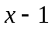). Hence function has one asymptote at 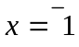
y goes to x only when 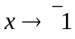 Answer (i)

Question 15

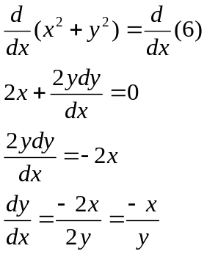

Answer (iv)

Question 16

If 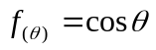 then it has period π.
Then 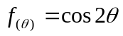then it has period 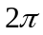
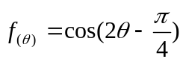has some period but it has phase change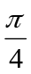
Answer (i)

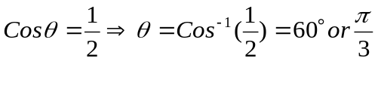 Question 17

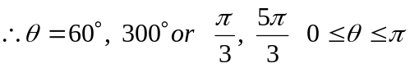
Answer (ii)

Question 18
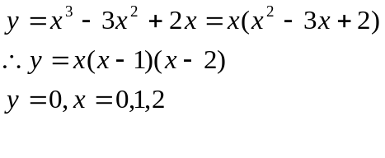

Curve cuts x =axis
x = 0,1,2 are cutting position on x-axis Answer (iv)

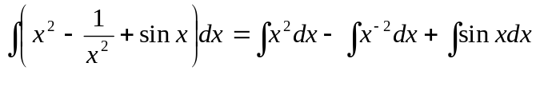Question 19

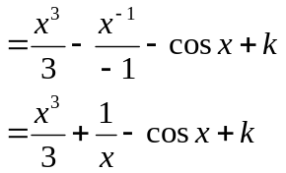

Answer (iv)

Question 20

= e³⁽³⁾ – e⁰
= e⁹ – 1
Answer (iii)

Question 21

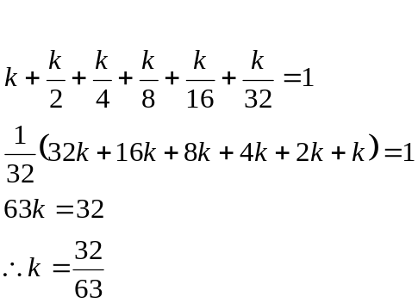

Answer (ii)

Question 22

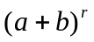 is any binomials expression and it’s r^{th} tern is 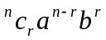
Then (1-2b)⁴ expansion according to 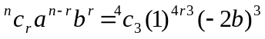
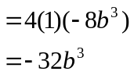
Coefficient of b³ is -32

Answer (iii)

Question 23
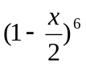 r^{th} term is 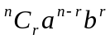
Hence first three terms are,

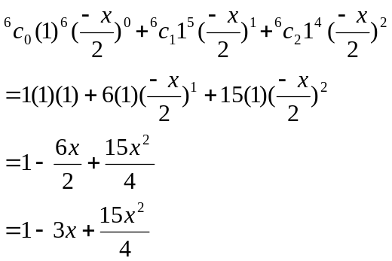
Answer (iii)

Question 24

BBBB is all four balls are blue colour ones. Next, one ball is yellow and others are blue colour ones. Possible ways are,
BBBB +YBBB +BYBB +BBYB +BBBY
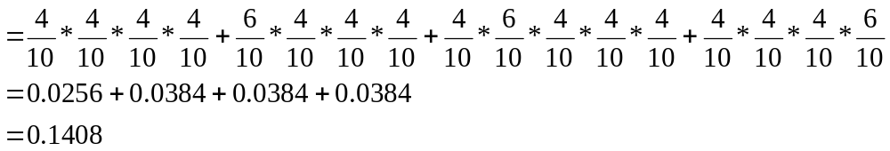
Probability that at least two yellow balls
= 1- (Probability of no yellow ball + probability of one yellow ball)
= 1- 0.1408
= 0.8592
=0.86 to 2 d.p. Answer (ii)

SECTION B - Written Examination 2: Analysis Task Suggested Solutions

Question 1
a. The function 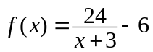does not allow 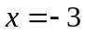. Thus the largest domain is R\{-3}.
1 mark

b. Applying following transformations for the graph 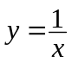 we can obtain the graph of

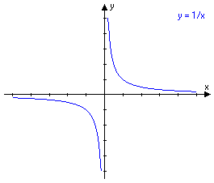
i. First, dilate by a factor of 24 in a vertical direction away from the x-axis.
1 mark
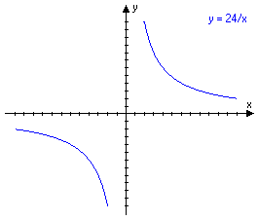

ii. Second translate the graph to the left (in a negative direction) along the x-axis by 3 units.
1 mark

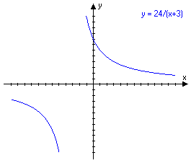

iii. Third, translate the graph down (i.e. in a negative y-direction) by 6 units.
1 mark

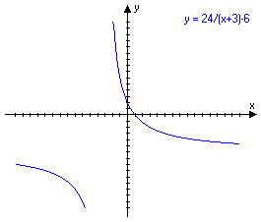

c. When 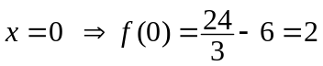 and when 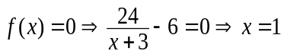
∴ Graph passes through the point (0,2) and (1,0).
1 mark

d. i.
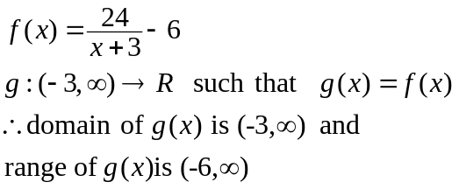
1 mark

ii.
If 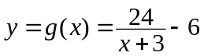 then inverse function of g(x) is given by
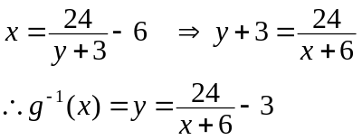
2 marks

iii When 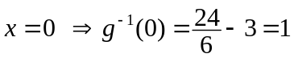 and when 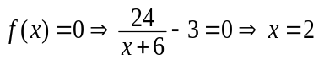
∴ Graph passes through the point (0,1) and (2,0). 1 mark

iv. Domain of 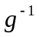 is the range of g.
∴the domain of is (-6, ∞). 1 mark

v. Solutions of 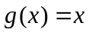 is given by

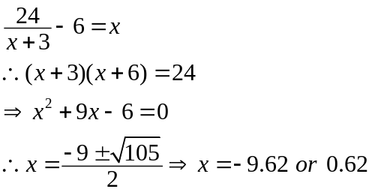
1 mark

∴Solution in the domain of g is 0.62
1 mark

g(x), take the same value on the line . Hence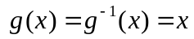 is satisfied when 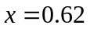. 1 mark

vi.
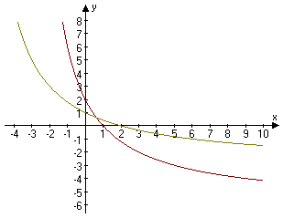
2 marks
Total 15 marks

Question 2
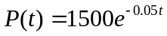
a. 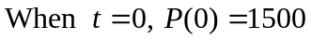 1 mark

b. When 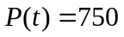.
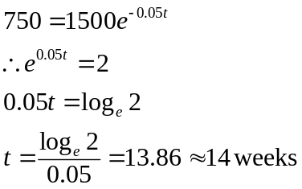
1 mark

c. 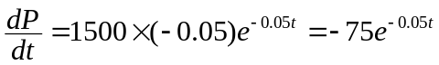
1 mark

d. i. When 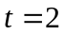
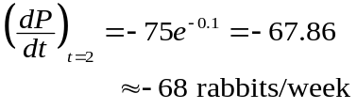

1 mark

ii. When 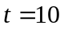
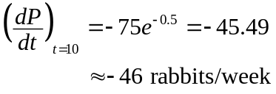
1 mark

e. Domain is [16,∞). 1 mark

f. 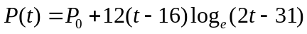
when 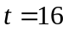 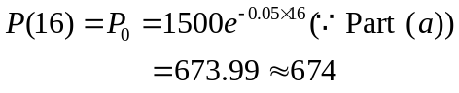
∴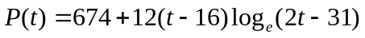
1 mark

g. When 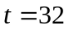

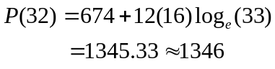
1 mark

h. 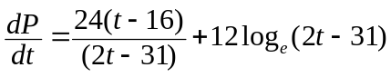
2 marks

i. i. When 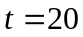

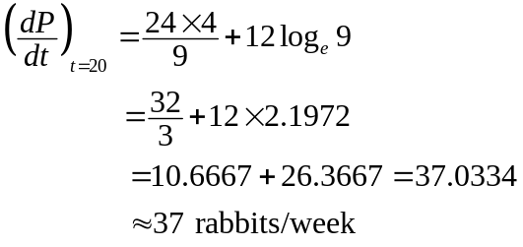
2 marks

ii. When 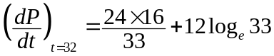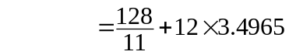
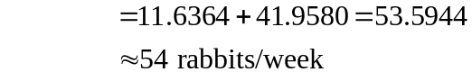
2 marks

j. Size of the population at time t is given by

Suppose that population takes t weeks to get back to its original number. Initial size of the population is 1500.
∴ when 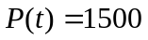 we have
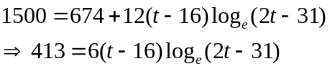

∴t is a solution of the above equation.
1 mark
Total 15 marks

Question 3

a. i.
This shape can be considered to be a sphere plus a cylinder. The volume is
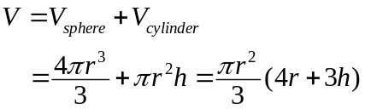
2 marks

ii Surface area of this capsule can be considered to be surface area of a sphere plus surface area of the curved surface of a cylinder.
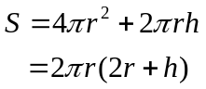
2 marks

b. i. Given that 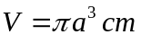

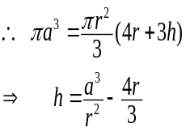
1 mark

ii. To find the domain for h consider the above expression. we know that
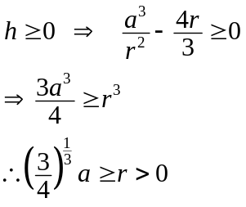
2 marks

iii
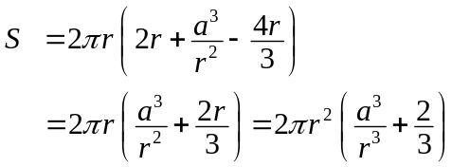
1 mark

c. i.
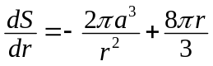

Turning points are given by 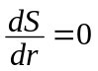
∴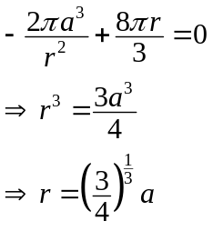 2 marks

ii.
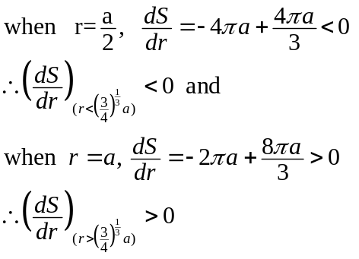
2 marks

Hence 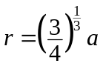is a minimum point
Corresponding value of S is given by
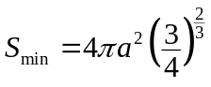

iii.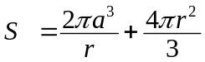
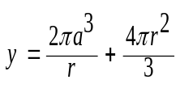

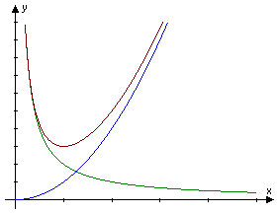
3 marks
Total 15 marks

Question 4

a. Let p the probability that he gets a particular answer correct. Then 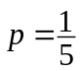.
1 mark

b. Binomial distribution with 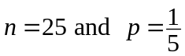. 1 mark

c. Random variable X denote the number of correct answers. Then the distribution of X

is 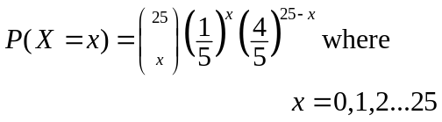
1 mark

d. The mean is given by
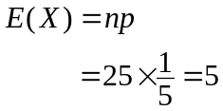
1 mark

Variance of X is given by
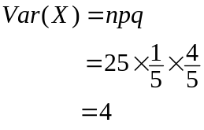
1 mark
The standard deviation is given by
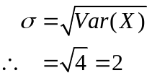
1 mark

e.
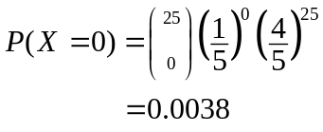
1 mark

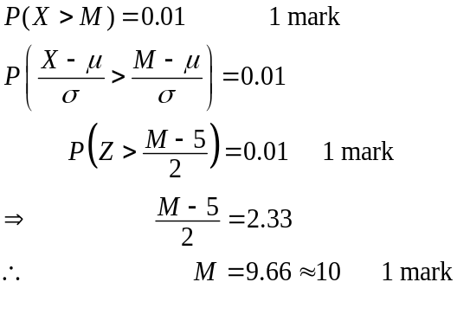
3 marks

Total 10 marks

